**INSTALLATION OF MONGODB**

**AIM**: To understand the installation and configuration of NoSQL Databases.

MongoDB is a cross-platform, document oriented NoSql database that provides, high performance, high availability, and easy scalability. MongoDB works on concept of collection and document.

**STEP 1:**

Navigate to the official MongoDB website.

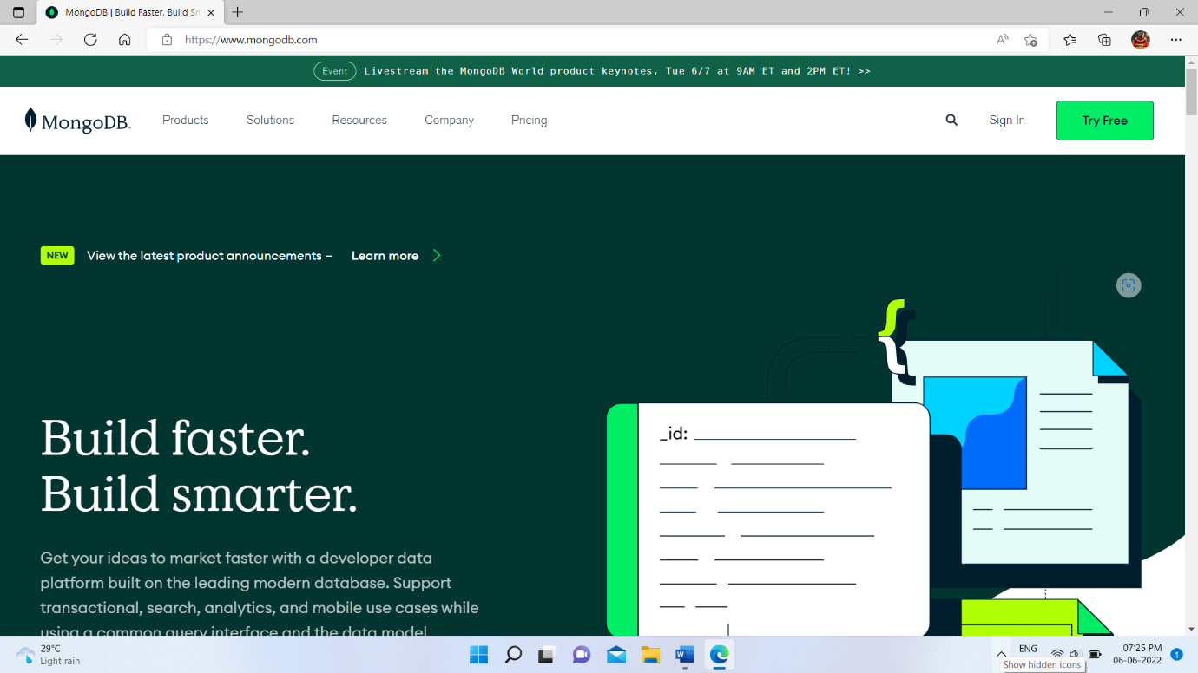

**STEP 2:**

Under the products section, click on the Community server version. Make sure that the specifications to the right of the screen are correct. At the time of writing, the latest version is 4.4.5. Ensure that the platform is Windows, and the package is MSI. Go ahead and click on download.

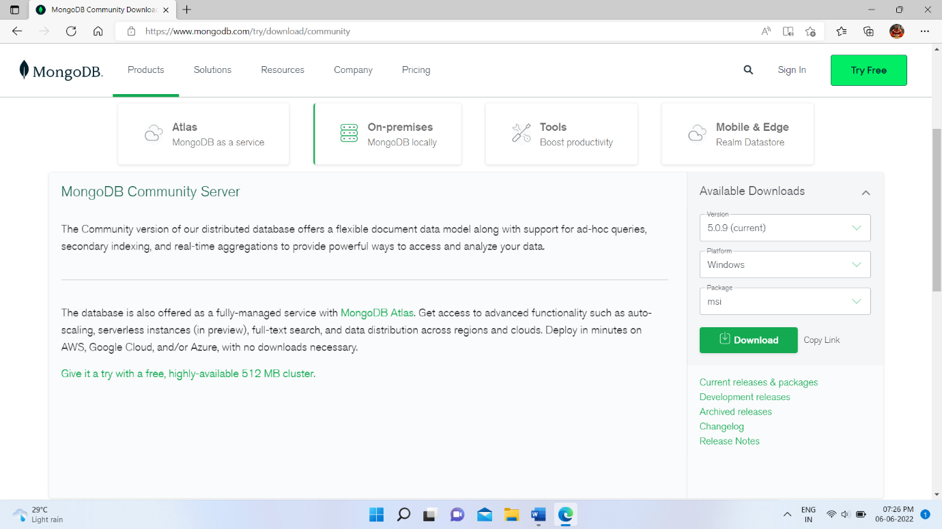

**STEP 3**:

You can find the downloaded file in the downloads directory. Install the software step by step.

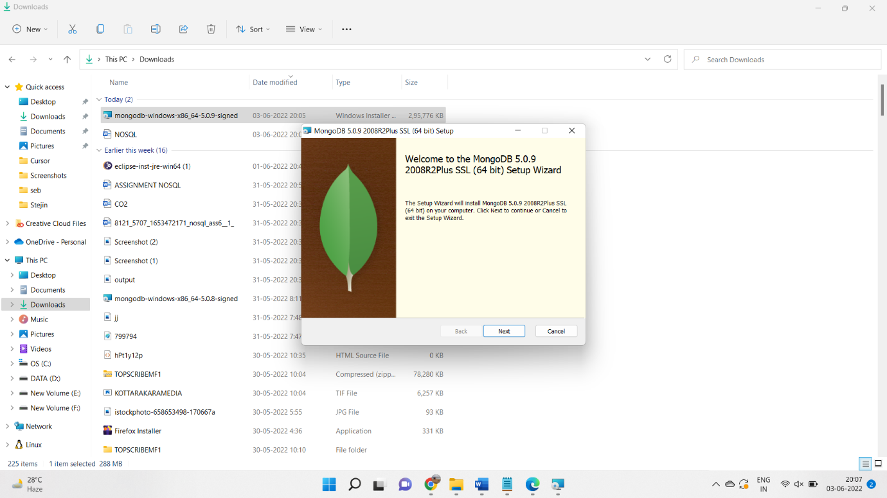

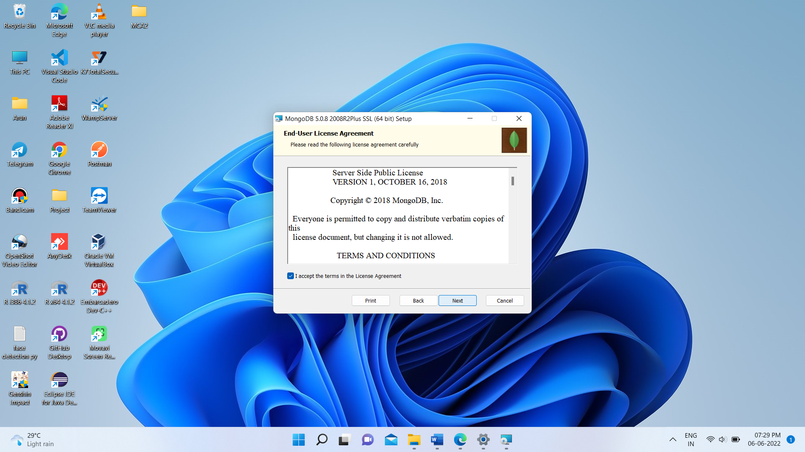

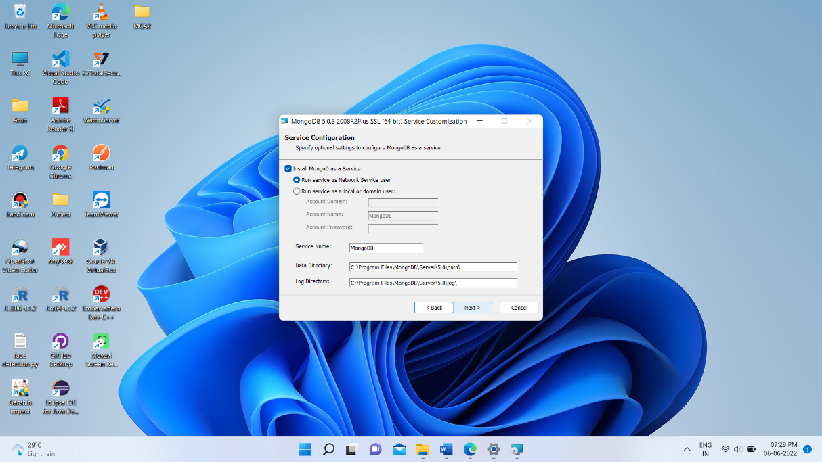

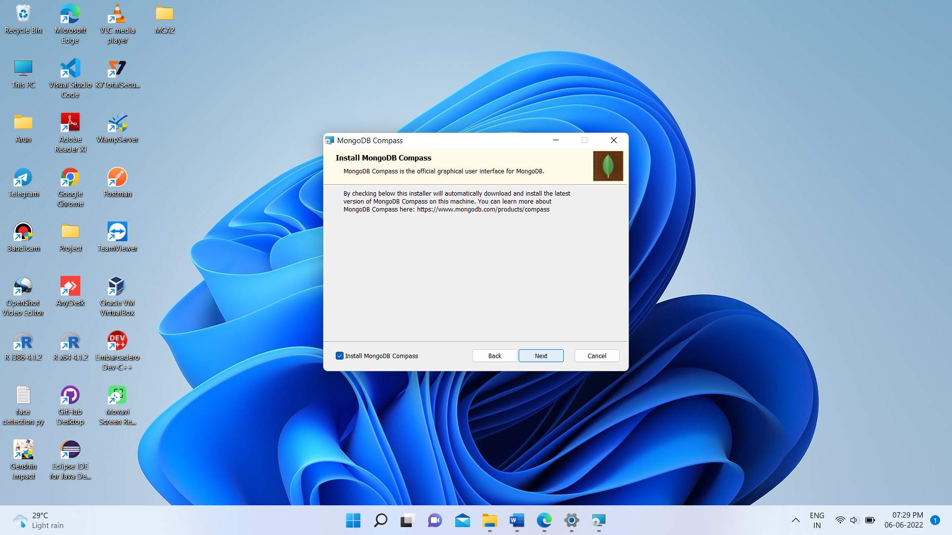

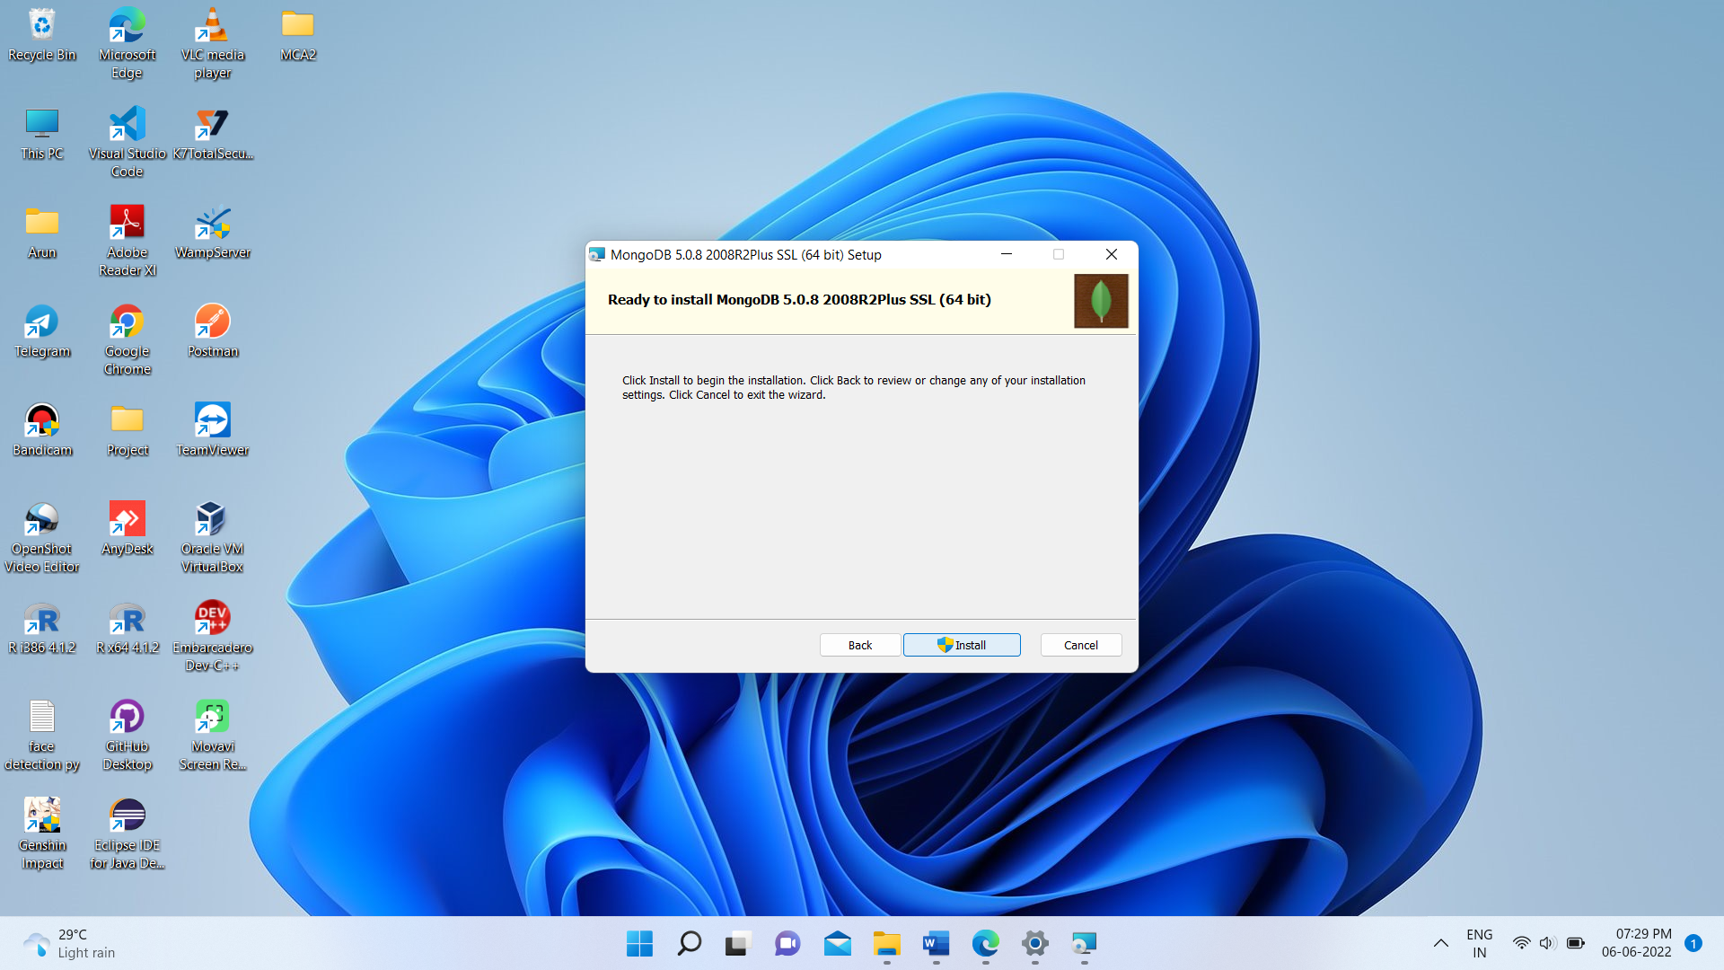

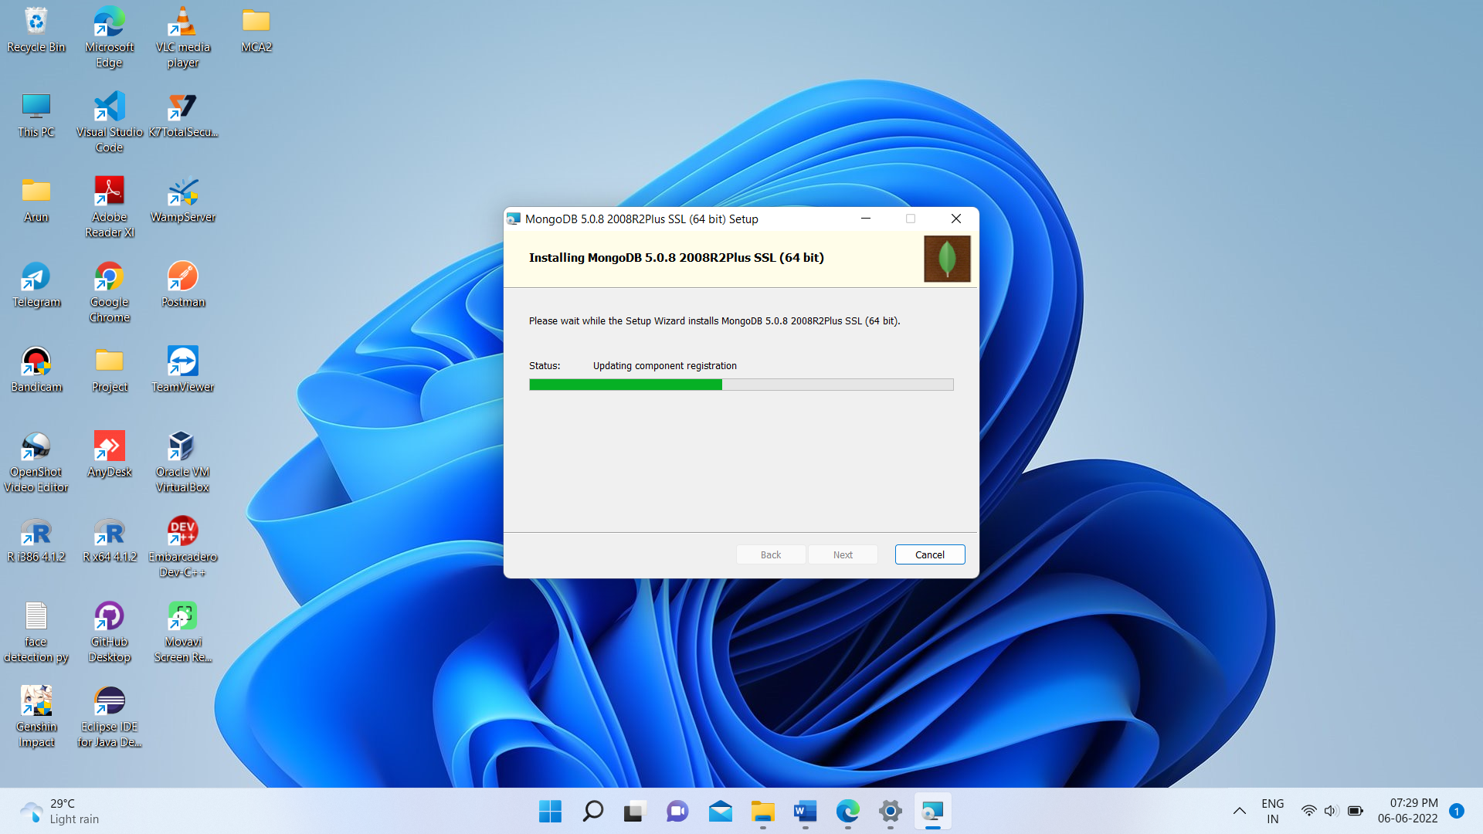

**STEP:4**

create an environment variable for the executable file so that we don’t have to change the directory structure every time we want to execute the file.

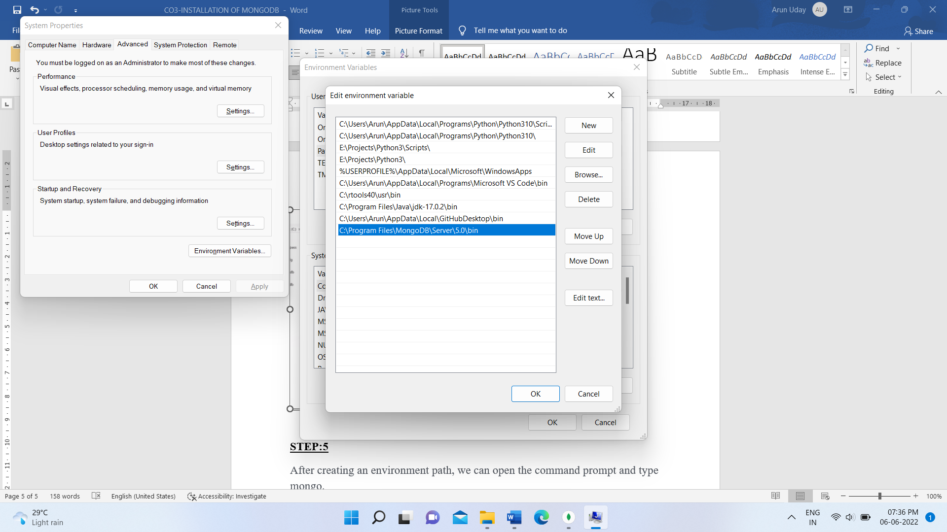

**STEP:5**

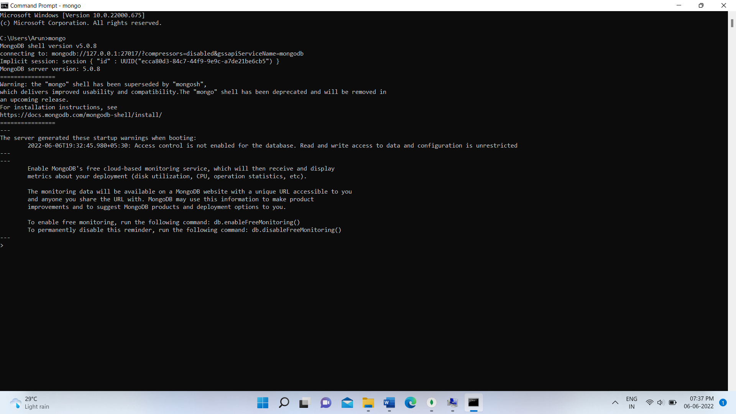After creating an environment path, we can open the command prompt and type mongo.